Wevo sealants and adhesives for fuel cells

Ostfildern-Kemnat, Germany. Hydrogen-based fuel cells achieve high performance and are energy-efficient. They produce no harmful emissions because only water and electrical energy are released when hydrogen reacts with oxygen. The technology therefore holds considerable potential for powering electric vehicles in the context of the proposed mobility transition. Since hydrogen is the smallest of all molecules, the adhesives and sealants used for fuel cells must ensure a very tight seal in order to prevent diffusion. WEVO-CHEMIE GmbH has developed silicones and polyurethanes especially for this purpose, and their low gas permeability has been confirmed by ZBT, the hydrogen and fuel cell center in Duisburg. The products can be used both for fuel cells themselves (“stacks”) and in the surrounding system (“balance of plant”).

Fuel cells consist of several functional layers, including two bipolar plates (see figure) which, amongst other things, ensure a uniform supply of hydrogen to the cells. Reliable sealing is essential here, because hydrogen is flammable and can form explosive mixtures (“oxyhydrogen”) in an oxygen-containing atmosphere. The sealing materials must not only be highly impermeable to gas; they must also be resistant to challenging conditions such as continuous high temperatures of up to 120 °C or low pH.

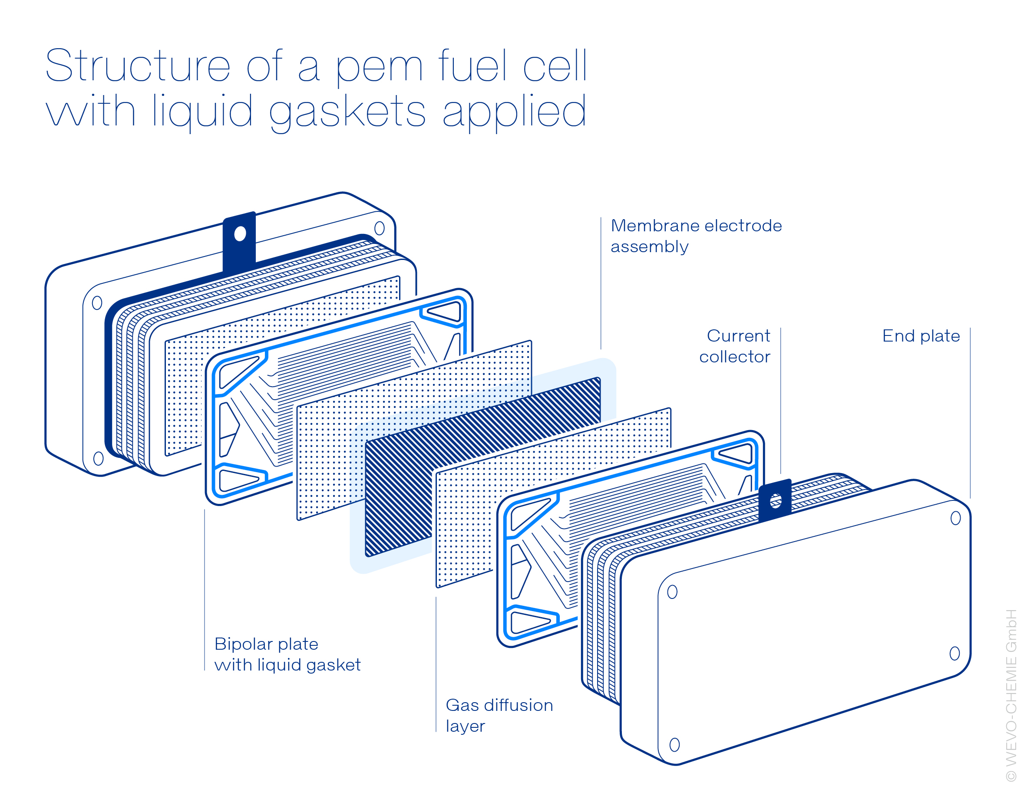

Up to now, preformed inlay gaskets have been used for this purpose, for example. However, due to the need to insert them manually on both sides of each bipolar plate, they are not suitable for automated production of high volumes, i.e. for the automotive sector in particular. Furthermore, there is a risk that they will detach the bipolar plate during stacking, so that they no longer seal effectively. The commercially available, addition-curing silicone liquid gaskets that are on offer as alternatives likewise have drawbacks, such as their generally high gas permeability and their poor adhesion to the majority of substrates. Wevo therefore developed special, chemically resistant, two-component materials based on polyurethane and silicone for use in proton exchange membrane (PEM) fuel cells. They are applied as liquid formed in-place gasket and also have further advantages for the manufacture and operation of fuel cell components.

Low gas-permeable materials from Wevo

The unusually low gas permeability of these materials has been confirmed by ZBT, the Duisburg hydrogen and fuel cell center, which is one of the leading research institutes in Europe in this field. One of the silicone-based products exhibited a very low hydrogen permeation coefficient of about 130 E-8 cm²/s after a measurement time of 16 hours (a figure between 500 and 1000 E-8 cm²/s is typical for addition-curing silicones). Moreover, adhesion to metal surfaces was optimised by Wevo and compression set reduced.

Wevo’s polyurethane sealants, which have similar thermo-mechanical properties to silicones, have even lower hydrogen permeability depending on the Shore hardness setting. Their permeation coefficients vary between about 30 and 70 E-8 cm²/s, also after a 16-hour measurement period. What’s more, these products adhere significantly better than silicones to the different substrates of bipolar plates. This prevents the seal from detaching either in the course of the manufacturing process or during stacking, so that loss of sealing effect is no longer an issue. Last but not least, much faster curing is possible compared to silicones – a major asset when it comes to automated production of high volumes.

Adhesives for stacks, bop components and electrolysers

Wevo’s polyurethane-based products can additionally be used as adhesives for other applications in the fuel cell stack due to their good adhesion properties – for example to join the two half-shells of the bipolar plates or even to bond the entire stack together. In the balance of plant (BOP), that is the fuel cell system, the humidifier’s components can be reliably bonded in this way. This is because the high ion purity and low levels of volatile components (VOC) in the Wevo polyurethanes rule out damage to the sensitive membrane and with it a drop in performance. High hydrolysis resistance at temperatures up to 100 °C is ensured, too, by the special composition of the adhesives.

Further information as well as applications for Wevo’s polyurethane, epoxy and silicone-based products in the BOP – plus advice on their potential uses in electrolysis plants for the production of hydrogen – can be found in the detailed article on our website: https://www.wevo-chemie.de/en/news-press/detailpage/fuel-cells-gas-impermeability-seals-adhesives

Image description and source
The low gas permeability of Wevo’s silicones and polyurethanes has been confirmed in a study by ZBT, the Duisburg hydrogen and fuel cell centre (Image source: © hopsalka – stock.adobe.com).

Note
An overview of fuel cell products is also provided by a free webinar that Wevo will be holding at UL Solutions on 4 April at 3pm. Further information and registration: https://bit.ly/3IUZFKy

About Wevo

WEVO-CHEMIE GMBH is an international, independent, family-run chemicals company headquartered in Germany and with further companies in Asia, China and the USA. Wevo develops and manufactures innovative potting applications as well as special bonding and sealing applications based on polyurethane, epoxy and silicone – primarily for applications in electrical and electronic components. Wevo products protect sensitive components against chemicals, vibration, foreign bodies, dust, moisture and high temperatures.

Press contact

Alexandra Heißenbüttel
Dr. Neidlinger Consulting
Phone: +49 711 167 617-712
Email: press@wevo-chemie.com

